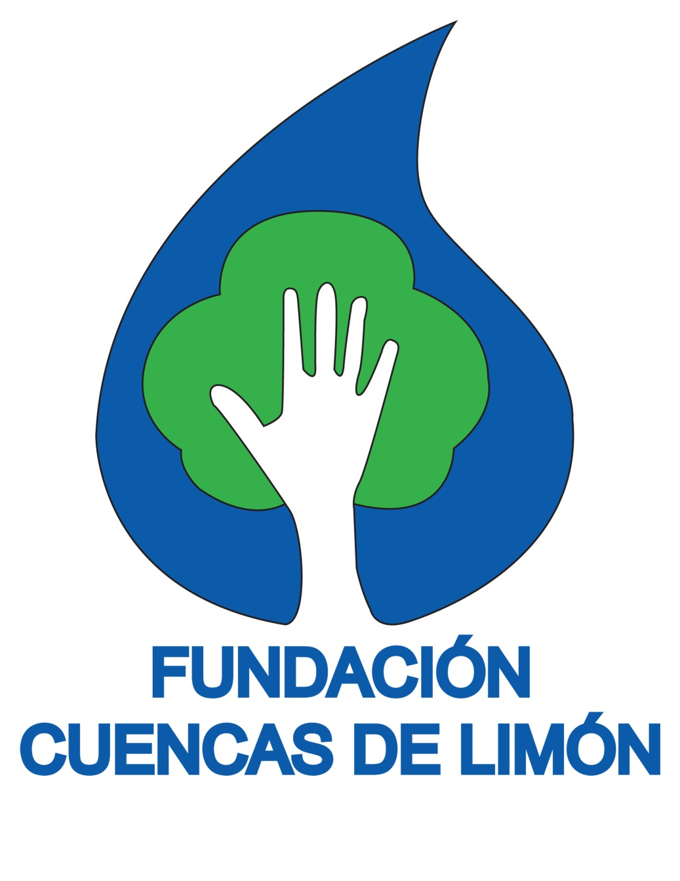
Corredor Biológico Selva Bananito (CBSB)

(Selva Bananito Biological Corridor)

Proposal For The Establishment of an Altitudinal Corridor
in Costa Rica

An ecological link between
Cerro Chirripó, Costa Rica’s
highest mountain peak,
and the Caribbean Sea
in the Province of Limón in
Costa Rica, Central America

January 2020

COSTA RICA
WWW.FCLIMON.ORG
FundacionCLimon@gmail.com (+506) 8723-4884
Fundación Cuencas de Limón: Who We Are
Fundación Cuencas de Limón (FCL), or Limon Watershed Foundation, was established as a nonprofit NGO in Costa Rica in 1996, in reaction to uncontrolled logging. Our mission is to protect the forested areas of the watersheds of the Banano and Bananito Rivers of the Province of Limón, in order to assure the water quality and supply for current and future generations. In our effort to reduce logging and encourage conservation, we have carried out many projects, several of which are important precursors to the corridor project proposed in this document. Most relevant are:
Changes in the Law. Fundación Cuencas de Limón proposed and was the driving force behind a decree subsequently approved by the Costa Rican Congress (No. 27998-MINAE), which requires land owners in environmentally fragile areas to carry out an environmental impact study to determine if they may log on their property. This decree applies to the whole country but helped FCL to protect over 10,000 ha of rainforest in the upper Banano River from irresponsible logging.
Establishment of Protected Areas. With the support of a regional watershed commission of which FCL is a member, and for which it also carries out all legal work, FCL was able to establish the “Zona de Recarga Acuífera del Rio Bananito (No.28024-MINAE)”, i.e., an area of 5,700 hectares (14,000+ acres) of privately owned land that now enjoys absolute protection status (see the No. 3 and No. 4 areas on the map on page 5). Furthermore, as a family we set aside over 1,000 hectares (2,470+ acres) of primary rainforest owned by us in order to establish a private reserve.
Watershed Management Plan. Together with several government entities and community representatives, FCL developed a multifaceted watershed management plan to ensure balanced and sustainable development within the watershed area. This Watershed Management Plan validates once again the importance of establishing a biological corridor, as it specifically points out the need to conserve and restore biodiversity by insuring connectivity between different bio-climates and ecozones.
Vegetation and Soil Use Study. We conducted an extensive land use study of the entire Banano and Bananito River Watersheds in order to identify the most viable routes for the corridor. The criteria used for this calculation were size of the area with natural coverage, degree to which this area was intact, closeness to rivers, and distance to roads.
Environmental Education. We carried out an award-winning campaign directed at 100,000 people, through which we increased awareness about the importance of the Banano and Bananito Rivers for the region, and the importance of reducing illegal logging. (Sponsor: www.rare.org)
Strategic Alliances. Over the years we have been able to form alliances with governmental entities, universities, and many other NGOs. These alliances will strengthen our ability to carry out the proposed biological corridor project. FCL is currently in talks with a Costa Rican government agency called FONAFIFO, which is in charge of carbon sequestration projects, with the aim of guaranteeing government payments for environmental protection along the corridor in order to generate alternative income for the land owners along the proposed route, and hence secure the sustainability of this project.
FCL has financed its projects through private donations, funding from other NGOs such as The Nature Conservancy, the UN Program for Small Donations, and RARE, strategic alliances with Costa Rican universities such as CATIE and Universidad Nacional de Costa Rica, and contributions from our own family business and savings. Since we are a very small NGO with a specific mission that hires consultants when needed, we have been able to keep our operating costs at an absolute minimum and are proud to say that we are known for our very cost effective, strategic, and well executed work.

What is a Biological Corridor?
A biological corridor - also known as a habitat corridor, wildlife corridor or green corridor - is an area of habitat connecting wildlife and plant populations separated by human activities or structures such as roads, development, farming, or logging (Wikipedia). A biological corridor is an area where native tree, shrub, and/or grass species are purposefully protected and re-established
Traditionally, conservation efforts have focused on securing important habitats, often through the creation of national parks and other protected areas. Nowadays it is clear that securing patches of land is not enough, and that it is essential to guarantee the flow of ecological processes between various ecozones to ensure the survival of many animal and plant species.
Fort short distances, something as simple as a "living fence" or thin forest strip can act as a biological corridor. The purpose of a biological corridor is to re-establish the exchange of individuals among populations, which may help prevent the negative effects of inbreeding and reduced genetic diversity (via genetic drift) that often occur within isolated populations. Corridors may also help facilitate the re-establishment of populations that have been reduced or eliminated due to random events such as fires or disease. Biological corridors allow species to gain access to resources they need to survive and become or remain stable, especially in the face of the accelerated changes we are seeing from climate change.

Urgency
Although we have been working toward the establishment of the corridor for a long time, the urgency to carry out this project has increased dramatically over the last two years. There are immediate plans to expand the Limon harbor significantly, and there are plans for new roads to neighboring areas of the proposed corridor. These developments constitute a serious and immediate threat to the integrity of the many areas that are still intact along the proposed route and will raise the real estate prices. We are also observing that climate change is becoming increasingly noticeable and urgent factor, both in terms of weather patterns and species being forced farther away from their usual habitats..
Proposal: Corredor Biológico Selva Bananito (CBSB)
Establishment of an altitudinal corridor: an ecological link between Cerro Chirripó, Costa Rica’s
highest mountain peak (12,500ft / 3,800m), and the Caribbean Sea in the Province of Limón.
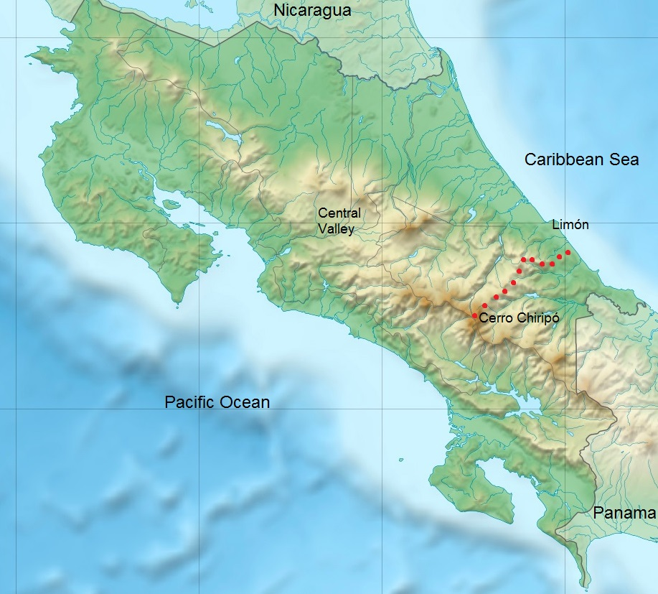

Relief map of Costa Rica indicating the proposed corridor route (red dots)
JUSTIFICATION FOR THE ESTABLISHMENT OF THE SELVA BANANITO BIOLOGICAL CORRIDOR (CBSB)
Biological rationale. Costa Rica is among the 20 top countries in the world for its biodiversity. The corridor expands through the Talamanca Region which in turn is the most biodiverse and least explored area of the country. In addition to depending on specific habitats, animal and plant species need space to migrate in order to ensure their survival in the intermediate and long run. The freedom to migrate between various altitudes and ecozones is not only essential to ensure nourishment and genetic dispersion and exchange, but also to adapt to environmental changes such as climate change. Costa Rica is considered a prime “hot spot” for climate change in the tropics (IPCC).
Human activity leads to land use changes and habitat fragmentation. To facilitate the survival of non-human species it is crucial to safeguard some connectivity among habitats, and hence to establish biological corridors in key areas. The proposed corridor connects ecozones across all possible altitudes in Costa Rica: from the highest mountain (3820m) down to sea level.
The areas that need to be secured and managed most urgently are located in the Caribbean Lowlands of Costa Rica, namely in the Bananito and Banano River Watersheds. This target area alone contains seven distinct forest categories.
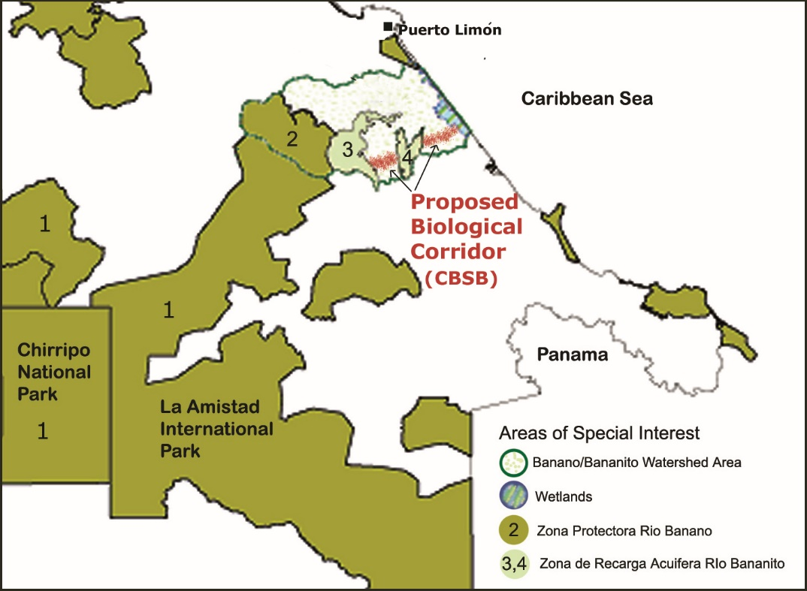
Human importance. The Bananito and Banano Rivers currently supply drinking water to about 80,000 people in Puerto Limón, Costa Rica’s main population center along the Caribbean coast, as well as to its surroundings. As the city grows and climate changes become more pronounced, clean drinking water will become increasingly scarce and valuable. Conservation work in the proposed area will not only be important for biodiversity, but also essential for human needs and public health.
Practical aspects. As the map to the left shows, many of the altitudinal ecozones within the proposed corridor are already protected under Costa Rican law. Already protected areas include: Chirripó National Park and La Amistad International Park (declared a World Heritage Site by UNESCO in 1982) (1), Zona Protectora Río Banano (2), Zona de Recarga Aquífera Río Bananito Oeste (3), and Zona de Recarga Acuífera Rio Bananito Este(4). The stretches that need to be joined are relatively short and extend between areas (3) and (4), as first priority, and as a second step, between (4) and the Wetlands by the coast. Hence, although the corridor extends from the Chirripó National Park to the coast, the actual work will concentrate in the Banano and Bananito River Watersheds (speckled area).

Map showing the Banano and Bananito River Watershed Areas (lightly speckled), as well as nearby national parks and other protected areas in southeast Costa Rica. Areas in dark and light green (1, 2, 3, and 4) are already protected. The proposed biological corridor is indicated in red.

SPECIFIC ROUTE FOR THE SELVA BANANITO BIOLOGICAL CORRIDOR (CBSB):
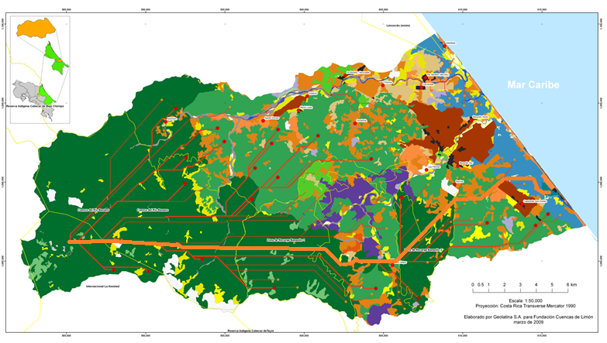
Fundación Cuencas de Limón has already conducted an extensive and detailed land use study of the Banano and Bananito watershed areas, shown in the map below (detailed legend available upon request). From it, we generated a computerized analysis to identify the most viable route for the CBSB, visible as the longest and thickest salmon/orange-colored line below.
Map of the Banano and Bananito River Watersheds, showing the exact trajectory of the CBSB, based on land use analysis.
ADDITIONAL ARGUMENTS FOR THE ESTABLISHMENT OF THE SELVA BANANITO BIOLOGICAL CORRIDOR (CBSB)
-Jaguars, pumas, ocelots, jaguarondis, and margays are continuously documented by wildlife cameras at the Selva Bananito Reserve in the upper parts of the Bananito watershed. The proposed corridor would expand the altitudinal roaming space for these felines. Other threatened animal species native to the proposed corridor area are the neotropical otter, Baird`s tapir, the red-fronted parrotlet, great curassow, and the great green macaw, as well as endangered plant species such as the cigar boxwood (Cedrela odorata) and the large-leaved mahagony (Swetenia humilis).
-The corridor is part of one of the most important habitats for bird migration in the world. La Amistad Biosphere Reserve hosts over 350 bird species, a third of which are North American migrants. The Talamanca lowlands constitute an important flyway for migrating raptors.
-The forest along the proposed corridor will reduce the amount of sedimentation that the rivers carry to the sea, which is threatening the health of the unique coral reefs along Costa Rica`s Atlantic coast.
Some Wildlife photos taken at the Selva Bananito Reserve
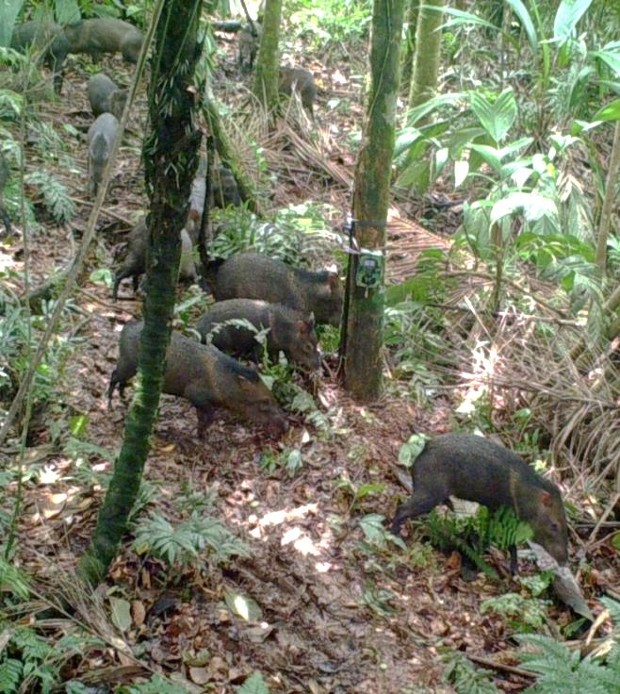
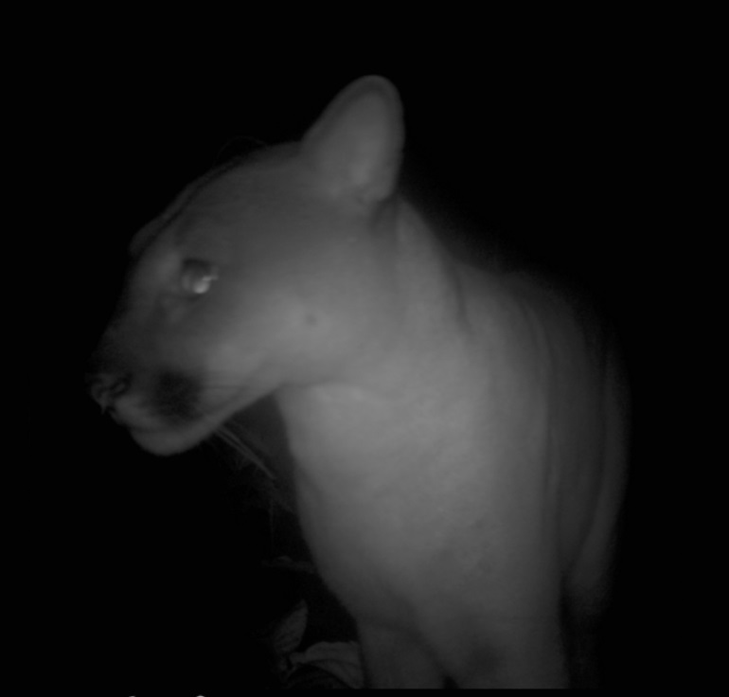
- Jaguar 2. Puma 3.White collared peccaries
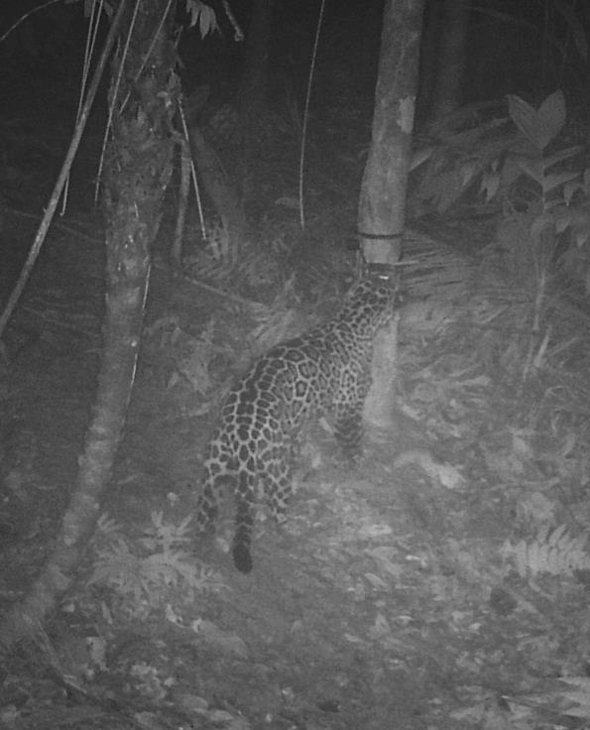
4. 5.

DETAILED PROJECT SUMMARY FOR THE SELVA BANANITO BOLOGICAL CORRIDOR (CBSB)
General Objective: To consolidate the Corredor Biológico Selva Bananito (Selva Bananito Altitudinal Corridor or CBSB) and achieve full connectivity between Cerro Chirripó and the Caribbean coast of the Province of Limón, Costa Rica

Specific objective | Rationale | Strategy
- Secure the necessary land to complete the corridor | To establish and guarantee land connectivity | 5Carry out a land-ownership study to identify owners along the proposed route  Buy/ lease/ rent identified land  Establish detailed maps
- To re-establish forests and richer feeding grounds on the most fertile soils. | Even though large areas of the CBSB are already protected under law, these already existing areas are located on mountainous terrain with poor soils and a lower potential for producing enough sustenance for animal species feeding on seeds. It is necessary to reclaim some of the better soils in the lowlands for the re-establishment of forests that have higher feeding potential and a greater carrying capacity. | Replant the most fertile grounds with plant species that enrich feeding areas.
- To establish a species inventory and monitoring system | An initial baseline and ongoing monitoring are necessary to measure the effectiveness of the corridor and to help make future management decisions for the corridor. | Monitoring through infrared cameras and footprint counts

Continuation

Specific objective | Rationale | Strategy
- To establish a surveillance system to stop illegal activities | Illegal hunting continues to be one of the major threats to wildlife integrity  Squatting and illegal logging also need to be identified before they cause damage to the protected areas | Regular surveillance against poachers  Occasional surveillance by plane to identify illegal squatting and logging activities  On-the-ground legal enforcement of logging, poaching and other violations
- To carry out environmental education and lobbying | Environmental education is necessary to achieve changes in human behavior and achieve long-term stability for the proposed Corridor.  Lobbying at governmental level is necessary to make sure that laws and regulations keep adjusting to our changing environmental needs, and that they are enforced properly. | The focus of the education program will change over time and be coupled with the stage of the proposed project. Initially, an anti-poaching program involving communities and the police force is essential.
- To establish funding mechanisms for further growth  of the corridor and future maintenance costs | Ensure future sustainability of the project; fund and negotiate complementary programs/projects | Generate income through CO2 capturing program and the payment of other environmental services  Establish strategic relationships with commercial entities that benefit from the conservation efforts, such as the regional banana companies.  Increase the donor base for the corridor project to establish a trust or endowment fund.

CHRONOLOGICAL SEQUENCE OF PROJECT
The proposed project is envisioned over a 5 year period, however, this time frame is largely dependent upon the availability of funds.
Securing the land has the highest priority in the sequence of events because land prices are rapidly increasing, and because being able to show that basic connectivity has been achieved, will make it easier to attract funding for the expansion of the corridor and for complementary activities. Securing the land is also the most expensive aspect of the corridor. Thus we have only estimated the funds needed to acquire the minimum amount of properties which would guarantee connectivity and would constitute the core strip or “spine” for the corridor. Over subsequent years, however, FCL wishes to continue widening the corridor either by raising additional funds to purchase more land, and/or by negotiating environmental service payments for landowners in return for the protection of their land. Both goals would be pursued within the initial five year period and beyond, and they constitute one of the project manager`s main tasks.
Since large areas of the corridor already exist and desperately need more active protection, most other activities, such as establishing a wildlife baseline, surveillance, and environmental education, can be started at any point in time once part of the funds have been secured. In this document, however, we propose for these activities to start during the second year of the project, once most land has been secured, because this may allow for a more effective use of the funds.

BUDGET
In this proposal, the budget is presented in two different ways. Table 1 shows the overall cost of the corridor. To possibly facilitate fundraising, Table 2 shows the approximate cost per activity.
Furthermore, the budget in both tables is divided in two sections. The “Basic Corridor” joins areas 3 and 4 shown on the map on Page 5, both of which are within the Bananito watershed. This is the most important stretch because it brings the corridor to a few meters above sea level. If the corridor stops there, it doesn’t reach all the way to the coast, but at least it would include most altitudinal ecozones characteristic of the Atlantic Basin. This option is the most cost effective because it would avoid the purchase of land right along the coast where real estate prices are highest. The “Full Corridor” extends the Basic Corridor all the way to the ocean and includes the ecozone called “humedal” (wetland area). As can be seen, this option is more expensive since more land would have to be acquired at higher prices, and subsequently managed.
In both tables below, the cost for the activities will remain stable unless we decide to modify their scope. The amount for the land acquisition is an approximation based on current land prices. Costs are expressed in U.S. dollars, and surface areas in hectares (ha).
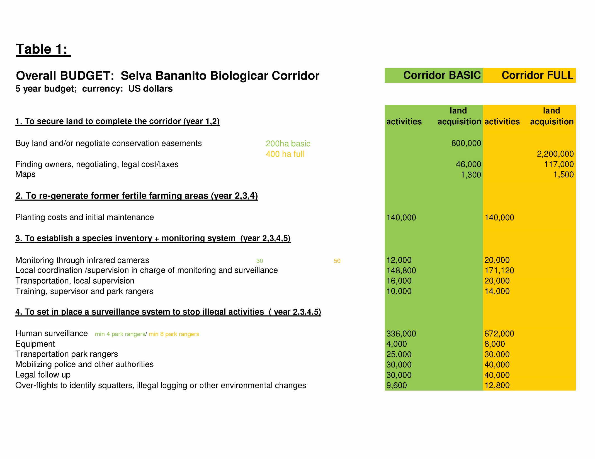
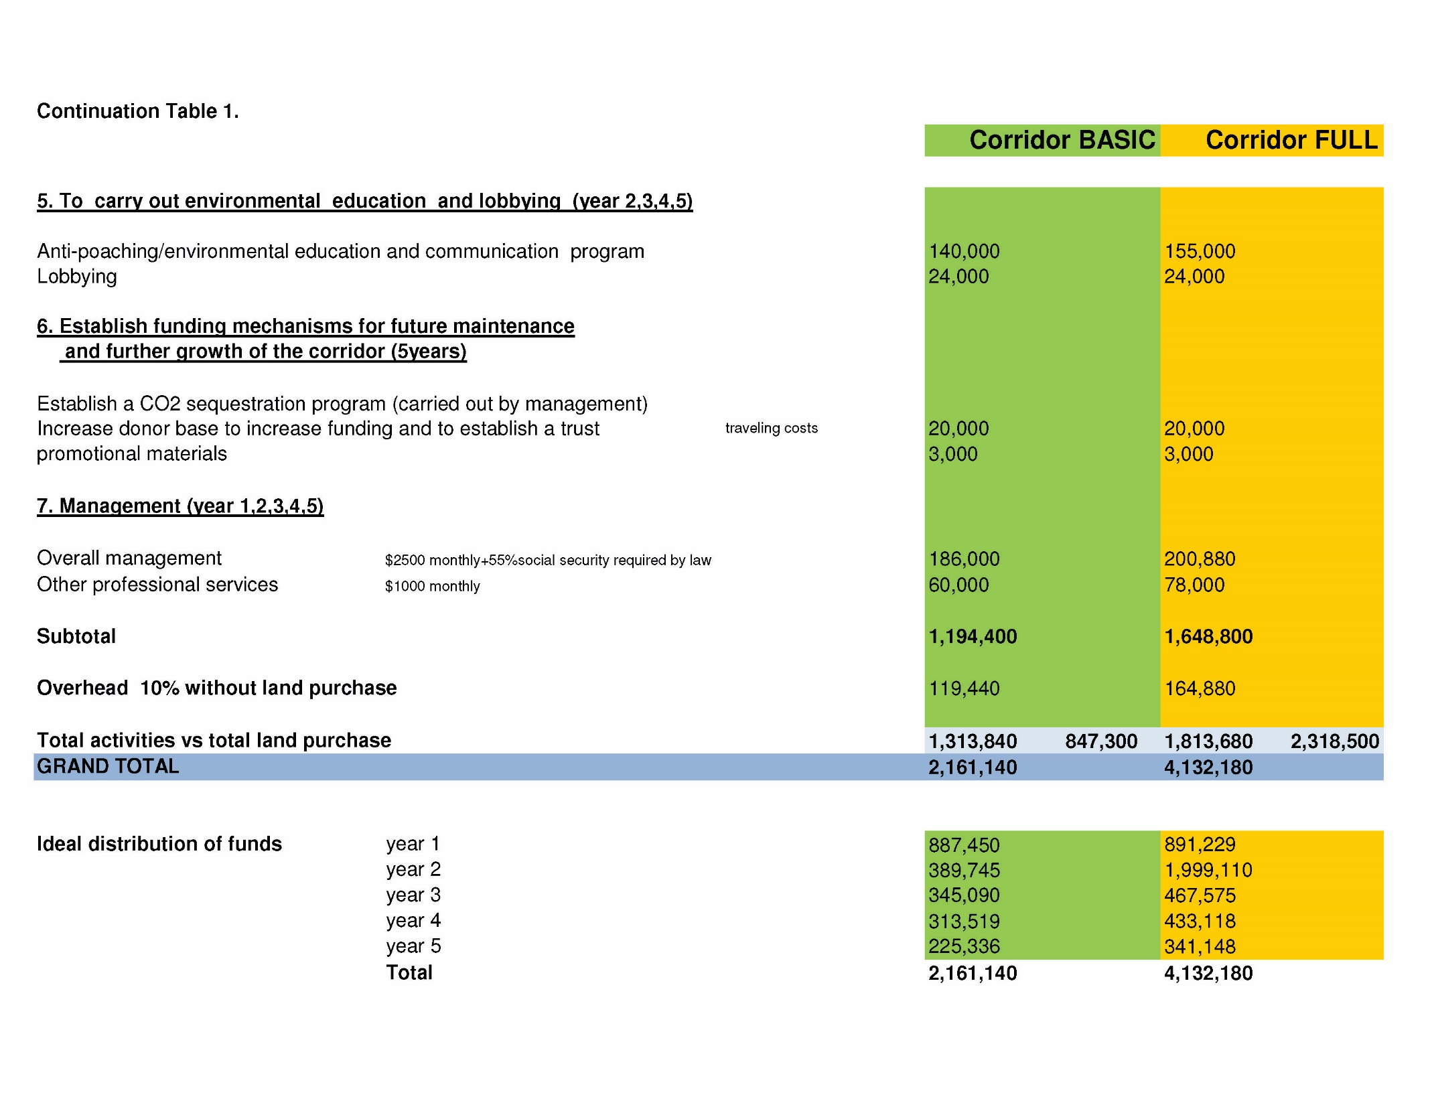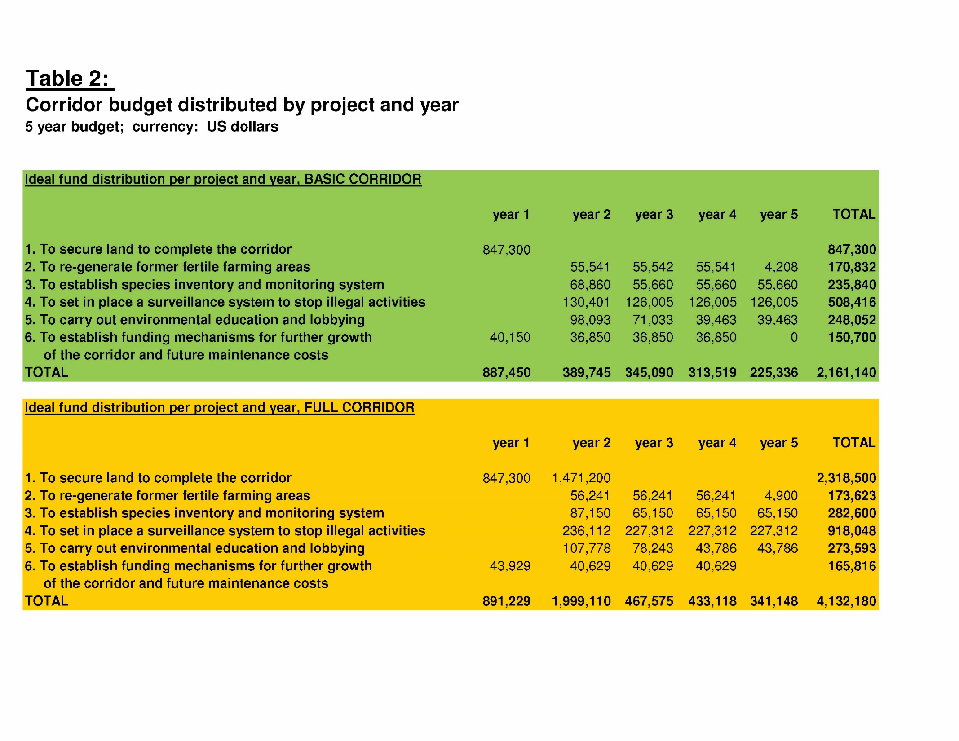OWNERSHIP
We would prefer the land to be purchased and owned by the donor in question. Under the by-laws of the proposed corridor, the new owner would sign a conservation easement or commit to low impact activities such as diversified reforestation projects. The land/funds can also be donated to Fundación Cuencas de Limón.
.
PROJECT PARTNERS, CONTRIBUTIONS TO THE PROJECT, AND ALREADY IMPLEMENTED STEPS
- Development of the watershed management plan by Fundación Cuencas de Limón, local communities and governmental agencies that validates the importance to preserve and improve the connectivity of the area (approx. $30,000 + community time+ government entity’s time).

- Land use studies that indicate the best route for the corridor (approx. $28,000 + community time)
- Land ownership study that identifies the maps and current ownerships of the land in question (approx. $6000)
- The existence of a 1000 ha large privately owned reserve within the proposed route (approx. $3,800,000)
- Property of 120 ha right by the coast owned by Dole Banana Company, that can also be integrated in the corridor (approx. $840,000)

- Current surveillance pilot project with 2 park rangers at the Selva Bananito Privat Reserve.

- 25 years of personal and institutional experience and devotion to the conservation of the Banano and Bananito Watersheds.

CONCLUSION
Fundación Cuencas de Limón wants to become the steward for a biological corridor that stops the fragmentation of attitudinally connected ecozones and restores at least one large area along which endangered species can move in a natural way, supporting their survival and diversity. We are seeking partners who can make this project happen and who have the capacity and the vision to safeguard natural treasures for future generations.
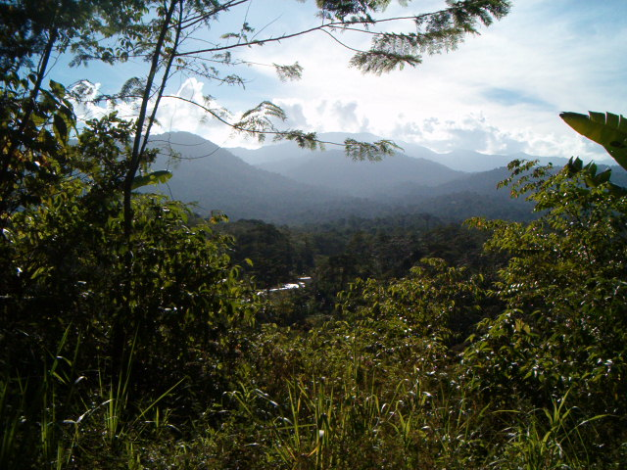
What is in it for all of us? The opportunity to give a voice to vanishing ecosystems, and hence a chance of survival to the rapidly disappearing plant and animal species in this highly biodiverse area. Furthermore, since the Biological Corridor would enhance the stabilization of the Banano and Bananito River watersheds - the primary sources of water for Puerto Limón, Costa Rica’s third largest city - we would be contributing significantly to a public health system that benefits many people.

View of the Bananito River and areas that would become part of the Corridor.

